Experiment Details

|  |  |
| --- | --- |
| Department Name | Computer Science and Engineering |
| Class | T.Y.BTech |
| Semester | I |
| Subject Name | Database Engineering |
| Experiment No. | 1 |
| Experiment Name | **ER Diagram**: Design an E-R Diagrams for different organizations and draw using any suitable software. |

Version History

|  |  |  |  |  |
| --- | --- | --- | --- | --- |
| Sr. No. | Version Number | Created By | Approved By | Date |
| 1 | v1.0 | Jay Deelip Kamble | Prof. Shivani Kale ma’am | 12/10/2020 |
|  |  |  |  |  |

**AIM:**

To design Entity Relationship Diagrams(ER Diagrams) for various organizations using suitable software tool.

**THEORY:**

An ER Diagram is a visual representation of data which describes various relationships between various entity sets.

* **Components of an ER Diagram:-**
* **Entity**:-An entity is an object in the real world that is distinguishable from other objects based on the values of the attributes it possesses.
* **Entity Set**:- Collection of same type of entities that share same properties or attributes. Simple rectangular box represents an entity set.

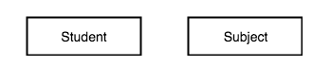

* **Weak Entity Set**:- Weak Entity Set is the entity set which depends on other entity set. It is represented using a double rectangle.



* **Relationship**:-A relationship is an association among several entities.
* **Relationship Set**:-A relationship set is a set of relationships of the same type. A rhombus is used to represent a relationship set.

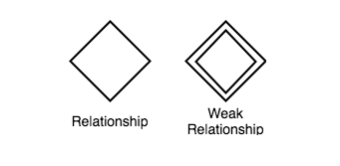

* **Degree of a Relationship Set**:- The number of entity sets that participate in a relationship set is the degree of the relationship set.
* **Binary Relationship**:- involve two entity sets (or degree two).
* **Ternary Relationship:**- involves three entity sets(or degree three)
* **Attributes:**-An entity is represented by a set of attributes, that is descriptive properties possessed by all members of an entity set.

Example:

instructor = (ID, name, street, city, salary )

course= (course_id, title, credits)

* **Types of attributes**:-
* **Simple and Composite Attributes**
* **Single-valued and multi-valued attributes:-**

 Example:-

multi-valued attribute: phone_numbers

* **Derived attributes:-**

 Can be computed from other attributes

 Example: age, given date_of_birth

* **Null attributes:-**Either missing or not known

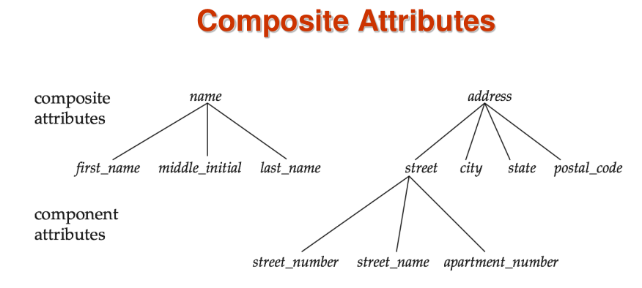

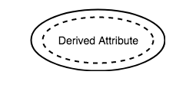

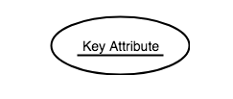

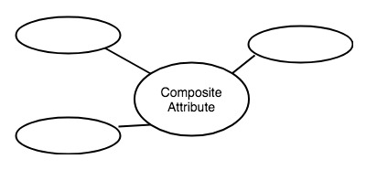

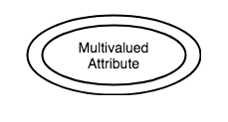

* **Constraints:-**

An E-R enterprise schema may define certain constraints to which the contents of database must conform.

* **Types of Constraints**:-
* Mapping Cardinality
* Participation Constraint.
* **Mapping Cardinality Constraints**:-Mapping cardinality or cardinality ratio, express the number of entities to which another entity can be associated via a relationship set.

For a binary relationship set the mapping cardinality must be one of the following types:

* One to one
* One to many
* Many to one
* Many to many

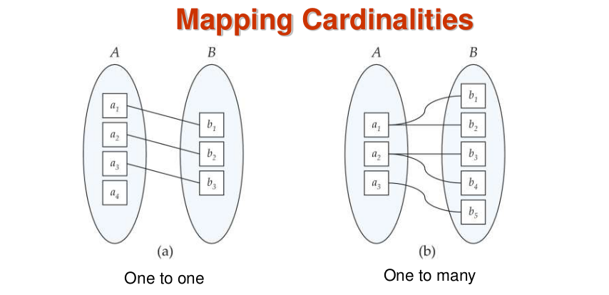

* **One-to-one**:- An entity in A is associated with at most one entity in B, and an entity in B is associated with at most one entity in A.
* **One-to-many** :- An entity in A is associated with any number (zero or more) of entities in B. An entity in B, however, can be associated with at most one entity in A.

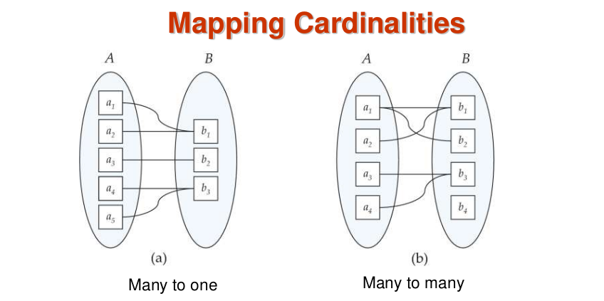

* **Many-to-one** :-An entity in A is associated with at most one entity in B. An entity in B, however, can be associated with any number (zero or more) of entities in A.
* **Many-to-many**:- An entity in A is associated with any number (zero or more) of entities in B, and an entity in B is associated with any number (zero or more) of entities in A.
* **Participation of an Entity Set in a Relationship Set:**
* **Total participation (indicated by double line)**: every entity in the entity set participates in at least one relationship in the relationship set.

E.g. participation of student in advisor is total

every student must have a instructor associated to it via advisor.

* **Partial participation**: If only some of entities in E participate in any relationship R in the relationship set.

E.g. participation of instructor in advisor is partial.

* **Keys**:- A key is a set of attributes that sufficient to distinguish entities from each other.
* **Super Key**:- A super key of an entity set is a set of one or more attributes whose values uniquely identify each entity.

(Id, name) is the super key of instructor

A super key may contain extraneous attributes.

* **Candidate Key**:-A candidate key of an entity set is a minimal super key

Id is candidate key of instructor

Although several candidate keys may exist, one of the candidate keys is selected to be the primary key.

* **Primary Key**:- Primary key is a candidate key, chosen by the database designer to identify entities within an entity set.

Primary key is a candidate key, chosen by the database designer to identify entities within an entity set.

It is denoted by underlining the attribute which is chosen as the primary key.

* **Dia Diagram Editor:-**

The open source tool Dia can be used to draw many different kinds of diagrams. It currently has special objects to draw ER diagrams, UML diagrams, flowcharts, network diagrams, and many other diagrams. It supports many common formats to store diagrams such as jpeg, png, eps, etc.

* **Dia can be installed and run on Window as follows:**
* Install dia software on windows
* Start dia by running 'dia' from the terminal or through the Applications >Dia diagram editor menu item.
* Dia opens with two windows, one is the tools window and one is the diagram window (canvas).
* **Dia can be installed and run on Ubuntu follows:**
* Install dia using the Ubuntu software center or by running the command 'sudo apt-get install dia'.
* Start dia by running 'dia' from the terminal or through the Applications > Graphics >Dia diagram editor menu item.
* Dia opens with two windows, one is the tools window and one is the diagram window (canvas).

**PRE TEST:**

**What is an Entity?**

1. **An instance of an Entity type that is uniquely identifiable**
2. An instance of a DBA type that is uniquely identifiable
3. An instance of a type that is uniquely identifiable

**How is an entity set represented in an ER diagram?**

1. Circle
2. Ellipse
3. **Rectangle**
4. Diamond

**How is a relationship set represented in an ER diagram?**

1. Triangle
2. Circle
3. Rectangle
4. **Diamond**

**What kind of technique is ER modelling?**

1. Bottom up
2. Left right
3. **top down**
4. none of the above

**Which of the following attributes can be used as primary keys?**

1. Department
2. Street
3. **ID**
4. name

**PROCEDURE:**

**1. Creating Entities:**

* 1. In the tools window, select the "Database" sheet from the dropdown below the tools.
  2. We use the Database "Table" component to represent entities. Click on the 'Table' component and click on the diagram window (canvas). An empty entity appears. Double click on the entity to edit its properties to open the properties window.
  3. Enter the following in the properties window:
     1. Table Name: enter the entity name
     2. Navigate to the attributes tab
     3. Click 'New'; Enter the name of the attribute. Check/uncheck the checkbox for primary key as necessary.
     4. Repeat step 3 for every attribute.
     5. Click OK.
  4. In the sample ER diagram, the entities User, Shopping Cart and Item have been created this way.
  5. Older versions of dia don't have the Database toolkit. As an alternative, you can use the Class construct in the UML toolbox to create entities, with attributes in a manner similar to the Table component above. In this case you will have to make the visibility of attributes implementation dependent to ensure they are not prefixed with # or +; you can mark an attribute as class scope to get it underlined. You should turn off show methods, so only attributes are shown.

1. **Adding relationships:**
   1. In the tools window, select the "ER" sheet from the dropdown below the tools.
   2. Click on the "Relationship" component and click on the diagram window(canvas). A relationship shape appears. Double click on it to edit properties.
   3. Enter the name of the relationship eg. "Belongs to".
   4. Clicking on the button named "Identifying", indicates that one end of the relationship is a weak entity (Item in our example).
   5. Click OK.
2. **Adding Connectors (arrows):**
   1. In the tools window, select the "Line" tool.
   2. Click on the border of the entity from where the arrow has to start, and drag till the destination. Once the mouse has been released, the arrow appears.
   3. Double click on the arrow to edit its properties. The "End arrow" dropdown can be used to change the style of the arrow head, or remove the arrowhead completely (eg. The line from the user entity to the "has" relationship has no arrowhead)
   4. To show total participation using a double line, instead go the ER tooset, and choose the double line "participation" link. Edit its properties to set participation to total.

These shapes can be cut, copied and pasted and dragged around as necessary to make the diagram clean and easy to understand. Clicking on any component and pressing the "Del" key deletes that component. Once it is done, the ER diagram can be exported using the "File > Export" menu item. It can be exported to various formats.

**POST TEST:**

**Which of the following is/are true?**

Statement 1:- The number of records a relation contains is known as its degree.

Statement 2:- The number of tuples a relation contains is known as its cardinality.

1. Only 1
2. **Only 2**
3. Both 1 and 2
4. Neither 1 nor 2

**An entity set that does not have sufficient attributes to form a primary key is termed a __________**  
 a) Strong entity set  
 b) Variant set  
 c) **Weak entity set** d) Variable set

**What is the relation between the weak entity set and the identifying entity set’s association known as?**

1. **Identifying relationship**
2. Owner relationship
3. Existence relationship
4. Dependency relationship

**Other than _______ , A weak entity set can participate in any relationship.**

1. Domain Relationship
2. **Identifying Relationship**
3. Strong Relationship
4. Relational Relationship

**Which of the following is the restriction imposed to main the integrity of the data in the database?**

1. Cardinality Ratio
2. Mapping Cardinality
3. Participation Constraints
4. **All of the above**

**REFERENCES:**

* [Database System Concepts_6th_Edition- Korth, Sudarshan](http://210.212.172.190/moodle2021/mod/resource/view.php?id=1150)
* DATABASE SYSTEMS – Connolly and Begg 4th edition